

**Birla Vishvakarma Mahavidyalaya**

**Engineering Collage (An Autonomous Institution)**

**Vallabh Vidyanagar - 388 120**

**Affiliated to Gujarat Technological University**

**A.Y. 2023**

# Assignment : I

**Course Title:** Digital System Design

**Name:** Akshay Singh

**Id no:** 21EL083

**Batch:** A11

**Course Code:** 3EL42

**Q.1) Write a Verilog code for 2 x 4 Decoder.**

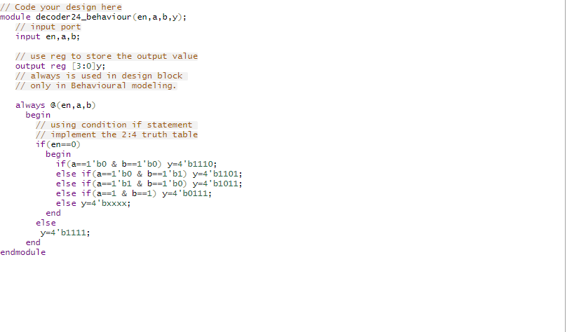

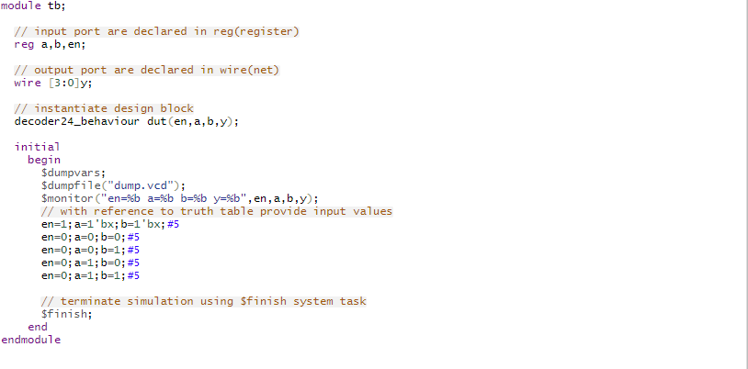

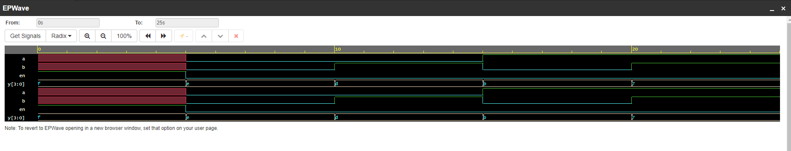

**Q.2) Write a Verilog code for 2-bit comparator.**

**CODE:**

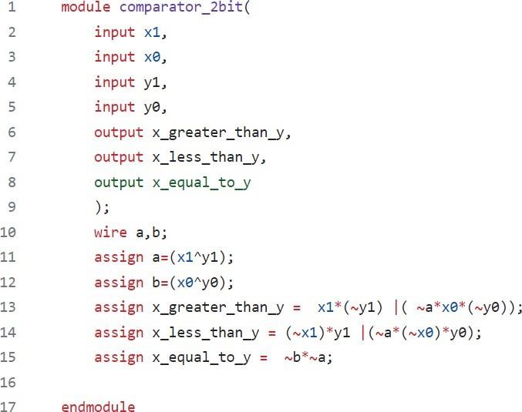

**TESTBENCH:**

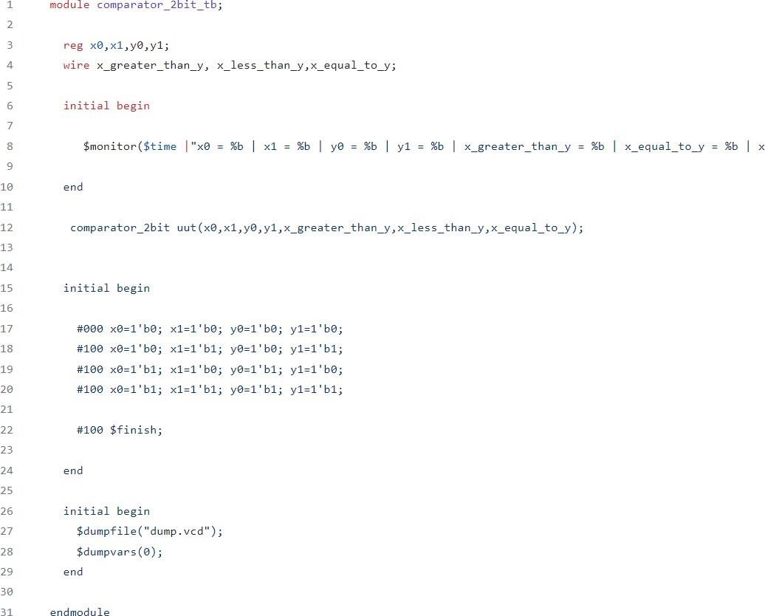

**OUTPUT:**

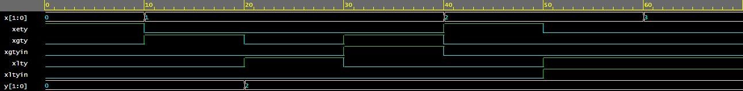

**Q.3) Write a Verlog code for Full Subtractor.**

**CODE:**

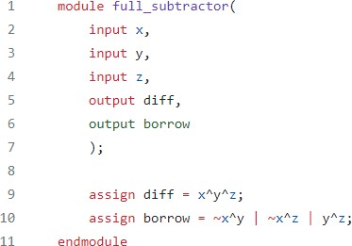

**TESTBENCH:**

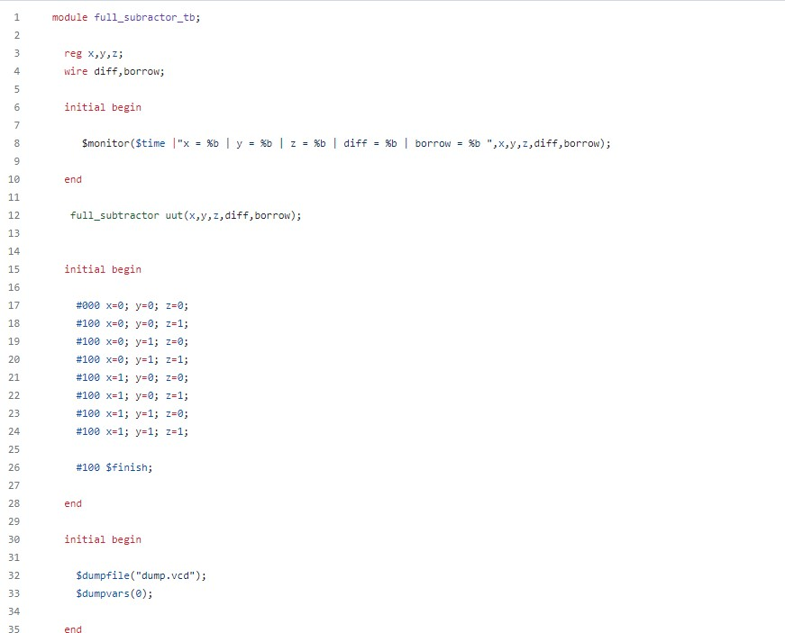

**OUTPUT:**

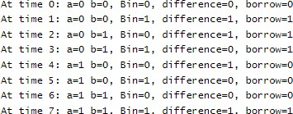

**Q.4) Write a Verilog code for 3 bit binary to gray converter.**

**CODE:**

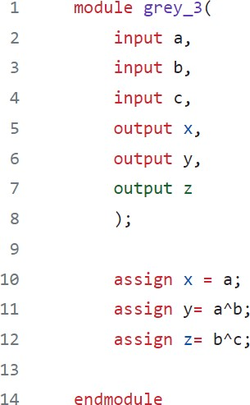

**TESTBENCH:**

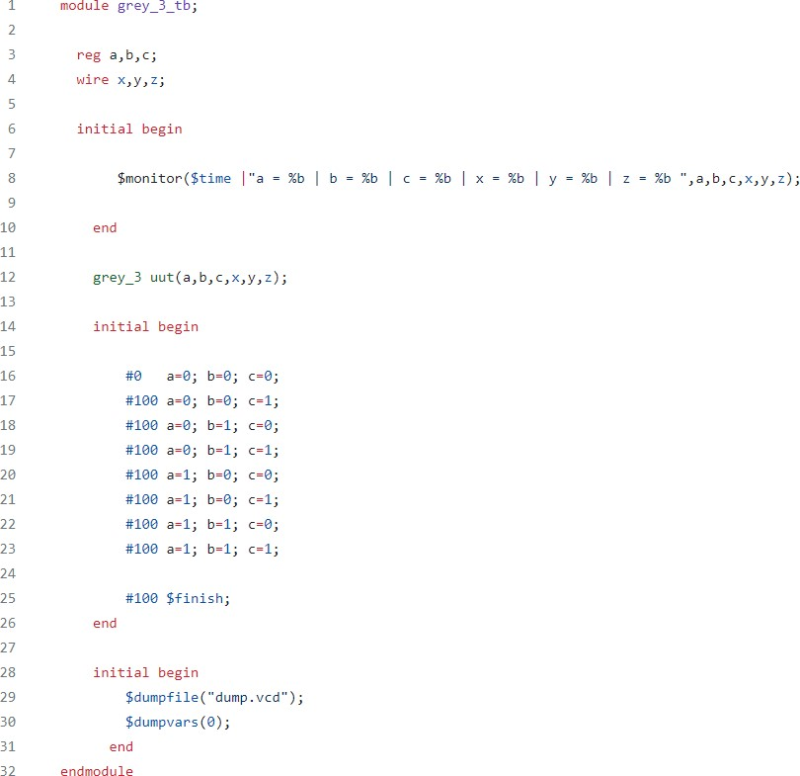

**OUTPUT:**



**Q.5) Write a Verilog code for BCD to excess 3 converter.**

**CODE:**

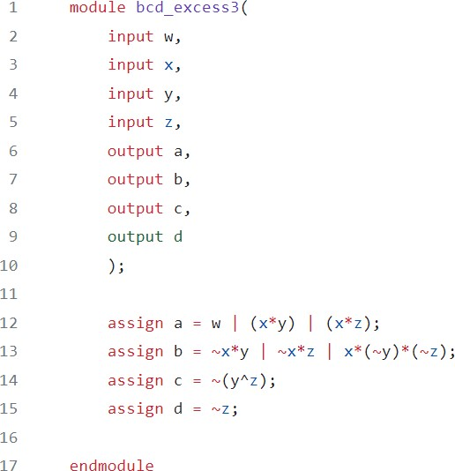

**TESTBENCH:**

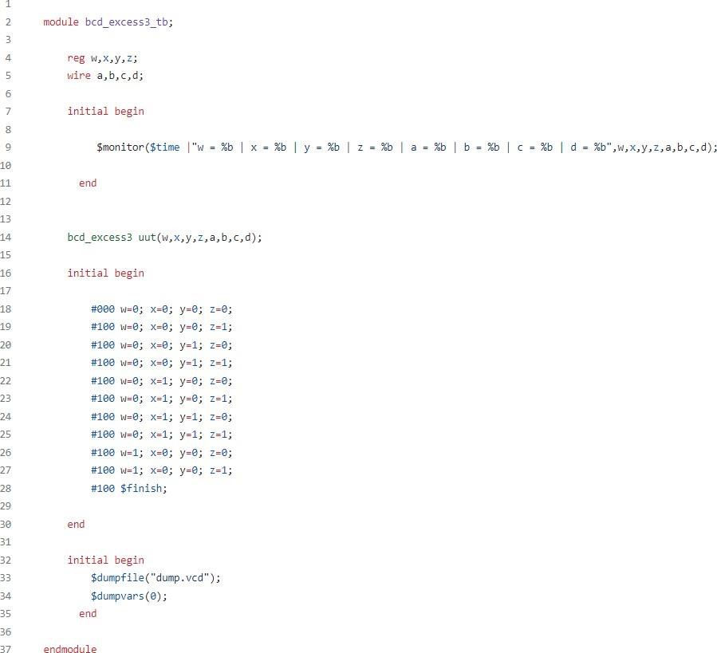

**OUTPUT:**

